Article Title
First Author^{1,*} [0000-1111-2222-3333] and Second Author² [1111-2222-3333-4444]
¹ Princeton University, Princeton NJ 08544, USA
first.author@princeton.edu
² Cairo University, Faculty of Economics and Political Science, Giza 12613, Egypt
second.author@cu.edu.eg
* Corresponding author: first.author@princeton.edu.com
Abstract. Rapid urbanization has steadily reduced the amount of green space available within city centers, raising concerns about its effects on residents’ physical and mental well-being. Parks, street trees and green roofs are known to lower ambient temperatures, filter air pollutants and provide residents with opportunities for physical activity and social interaction. Yet in many rapidly growing cities, green infrastructure is treated as an amenity to be added once other priorities are met, rather than as a core element of urban planning. This gap between recognized benefits and actual investment leaves many neighborhoods, particularly lower-income ones, without adequate access to green space.
This study examines how the distribution of urban green infrastructure relates to public health outcomes across neighborhoods with different income levels. Drawing on evidence from multiple metropolitan areas, the analysis suggests that consistent, equitably distributed investment in green infrastructure is associated with measurable reductions in heat-related illness and improvements in reported well-being. The findings point to the value of embedding green infrastructure planning into standard municipal budgeting cycles rather than treating it as a discretionary expense, and they highlight specific policy levers that city planners can use to close existing gaps in access (Carter, 2025).
Keywords: First Keyword, Second Keyword, Third Keyword (at least 5 keywords)

1 First Section

1.1 A Subsection Sample
The opening paragraph of any section or subsection should not be indented, and the same applies to a paragraph that immediately follows a table, figure or equation.
Every paragraph after that first one, however, should carry a first-line indent. When citing sources in the running text, Euromid Press asks authors to use the author–year format rather than numbered brackets. A single-author work is cited as (Carter, 2025), a work with two authors as (Carter & Elgharbawy, 2024), and a work with three or more authors as (Elhabib et al., 2023). When more than one source supports the same statement, list them together and separate them with a semicolon, e.g. (Carter, 2025; Elhabib et al., 2023).
Sample Heading (Third Level). Numbering is reserved for the first two heading levels only; anything below that stays unnumbered and is styled as a run-in heading instead.
Sample Heading (Fourth Level). A contribution should not go beyond four heading levels in total. Table 1 summarizes how each level should look.
Table 1. Table captions should be placed above the tables.
Heading level | Example | Font size and style
Title (centered) | Article Title | 14 point, bold
1st-level heading | 1 Introduction | 12 point, bold
2nd-level heading | 2.1 Printing Area | 10 point, bold
3rd-level heading | Run-in Heading in Bold. Text follows | 10 point, bold
4th-level heading | Lowest Level Heading. Text follows | 10 point, italic
Equations that are set apart from the text should be centered on their own line, as illustrated in Equation (1).
x + y = z (1)
For line-art diagrams and schematics, vector graphics are preferred over rasterized images wherever this is possible (see Fig. 1).
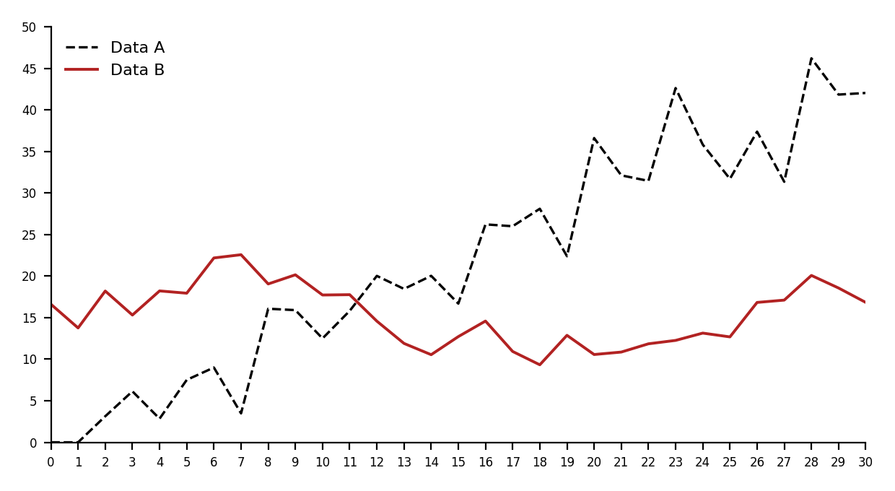
Fig. 1. A figure caption is always placed below the illustration. Short captions are centered, while long ones are justified.
Rather than numbering sources with square brackets, Euromid Press asks authors to identify each source by surname and publication year in parentheses, for instance (Carter, 2025). If the author’s name is already part of the sentence, only the year needs to be placed in parentheses, as in “Carter (2025) shows that…”. The list at the end of the paper illustrates this format across several source types — a journal article, a proceedings paper, a book, a conference contribution and a website — arranged alphabetically by the first author’s surname.

References
Carter, B. (2025). Digital transformation and economic diversification in emerging markets. Journal of Development Economics, 52(3), 99–110.
Carter, B., & Elgharbawy, A. (2024). Export concentration and growth volatility: Evidence from the MENA region. In F. Editor & S. Editor (Eds.), Proceedings of the Euromid Conference on Economic Policy (pp. 1–13). Euromid Press.
Author, F. (2010). Contribution title. In Proceedings of the 9th International Conference on Development Economics (pp. 1–2). Publisher.
Bakr, N., & Youssef, H. (2022). Urban green space accessibility and heat-related morbidity in North African cities. Urban Climate, 41, 101052.
Chen, L., Osei, K., & Rahman, T. (2021). Equity in park distribution: A cross-city comparison. Landscape and Urban Planning, 210, 104078.
Elhabib, M., Author, S., & Author, T. (2023). Diversifying developing economies (2nd ed.). Euromid Press.
Euromid Press. (2026). Euromid Press homepage. https://www.euromidpress.com (accessed 21 November 2025).
Farouk, S. (2019). Green roofs and building energy performance in arid climates (Master’s thesis). Cairo University.
Karimi, A. (2020). Nature-based solutions for climate-resilient cities. In R. Novak (Ed.), Handbook of urban resilience (pp. 145–168). Euromid Press.
Mensah, K., & Diallo, F. (2022). Financing urban resilience in Sub-Saharan Africa (Working Paper No. 2022-07). Euromid Institute for Urban Studies.
Ministry of Housing, Utilities and Urban Communities. (2022). National urban green space strategy 2022–2030. Government of Egypt.
Nassar, D., & Ibrahim, R. (2018). Public health benefits of street tree canopy: Evidence from Amman. Journal of Environmental Health, 80(4), 22–29.
Saleh, R. (2024, March 14). Cities race to green their streets before summer heat peaks. The Cairo Herald. https://www.cairoherald.com/cities-green-streets
United Nations Human Settlements Programme. (2021). Global urban green space database [Data set]. UN-Habitat. https://data.unhabitat.org/datasets/green-space
World Health Organization. (2023). Urban green space interventions and health: A review of impacts and effectiveness (Report No. WHO/EURO/2023-5678). World Health Organization.

Note: All references listed in the reference list must be cited in the main text, and all in-text citations must have corresponding entries in the reference list.

